Lab 7-2 Inheritance 2

1. Working in folder “week7”
2. Write the java program by using inheritance technique.(with your own design)
3. Compile and run the program.

The PET program

The program is including five classes Pet, Dog, Fish, and Bird. The class Pet use to define the kind of the animals. The class contain the properties species, name, color, and age. There are three kinds of pet in this program which are Dog, Fish , and Bird. The dog can define by the size of it (small, medium, and big) and short or long hair. Fish has properties freshwater or saltwater fish and the size. The bird has properties can fly and country. All of three kinds have the behavior which are run, swim and speak. (See all information in the picture)

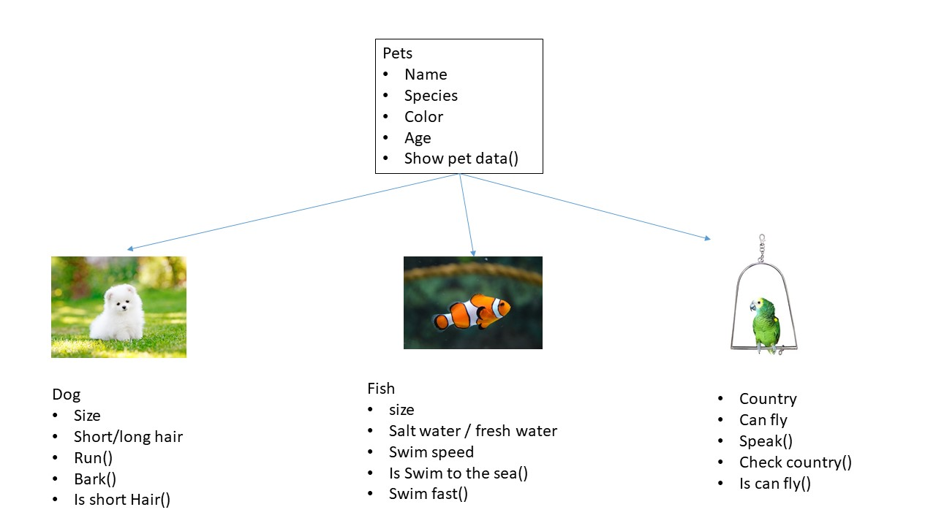

Example output

